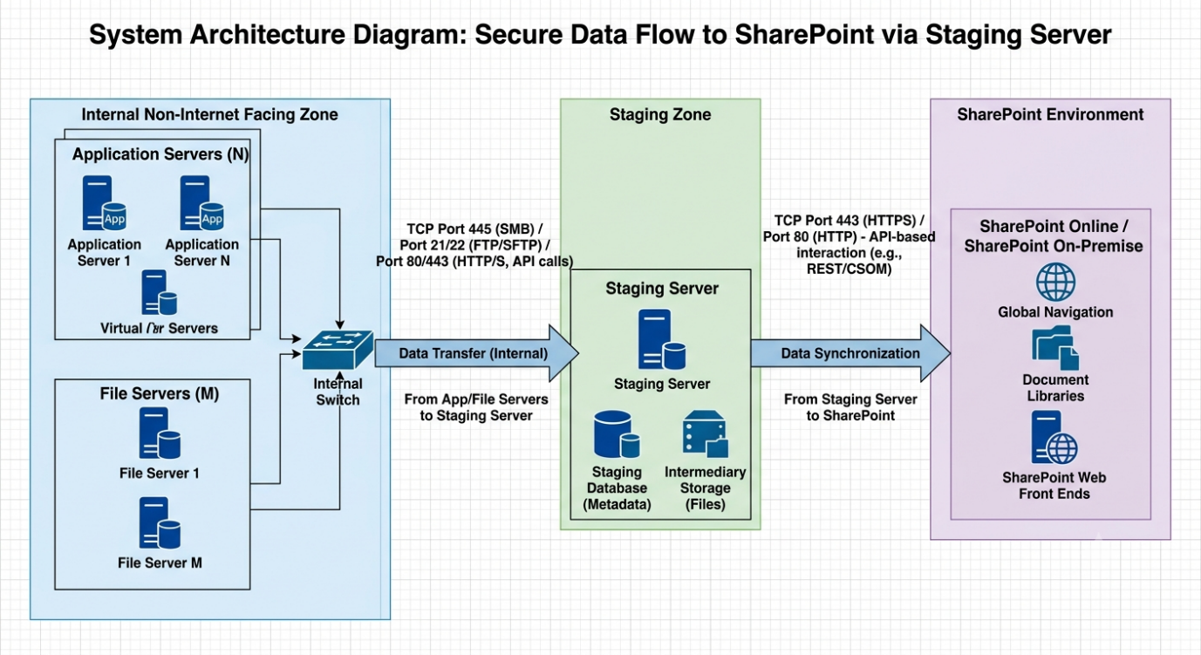

Below is a recommended architecture for securely transferring files from multiple non-internet-facing servers to SharePoint via a staging server located in a DMZ or integration zone.
Architecture Diagram
┌─────────────────────────────────────────────────────────────────────┐
│ INTERNAL SECURE NETWORK │
│ (Non-Internet Facing Zone) │
└─────────────────────────────────────────────────────────────────────┘

+----------------+ +----------------+ +----------------+
| File Server 01 | | File Server 02 | | Application Svr|
| Windows/Linux | | Windows/Linux | | ERP/CRM/etc. |
+--------+-------+ +--------+-------+ +--------+-------+
| | |
| SMB 445 / SFTP 22 | SMB 445 / SFTP 22 |
| HTTPS 443 (Optional) | HTTPS 443 (Optional) |
| | |
+------------+------------+------------+------------+
|
|
v
┌────────────────────────────────┐
│ Internal Firewall │
│ Allow only required ports │
└───────────────┬────────────────┘
|
|
v

┌─────────────────────────────────────────────────────────────────────┐
│ STAGING / INTEGRATION ZONE │
│ (DMZ Network) │
└─────────────────────────────────────────────────────────────────────┘

+--------------------------------+
| Staging Server |
| |
| - File Collection Service |
| - AV/Malware Scan |
| - Data Validation |
| - Logging/Auditing |
| - PowerShell / API Connector |
+---------------+----------------+
|
|
| HTTPS 443
| Microsoft Graph API
|
v

┌────────────────────────────────┐
│ DMZ / Perimeter Firewall │
│ Outbound HTTPS Only │
└───────────────┬────────────────┘
|
|
v

┌─────────────────────────────────────────────────────────────────────┐
│ MICROSOFT 365 │
└─────────────────────────────────────────────────────────────────────┘

+--------------------------------+
| SharePoint Online |
| |
| Document Libraries |
| Teams Files |
| Metadata Management |
+--------------------------------+

Recommended Port Matrix
Source | Destination | Protocol | Port | Direction | Purpose
File Servers | Staging Server | SMB | TCP 445 | Internal → Staging | File transfer
File Servers | Staging Server | SFTP | TCP 22 | Internal → Staging | Secure file transfer
Application Servers | Staging Server | HTTPS API | TCP 443 | Internal → Staging | API-based file upload
Staging Server | DNS Server | DNS | TCP/UDP 53 | Outbound | Name resolution
Staging Server | Active Directory | LDAP/LDAPS | TCP 389/636 | Outbound | Authentication
Staging Server | SharePoint Online | HTTPS | TCP 443 | Outbound | Upload files
Staging Server | Microsoft Graph API | HTTPS | TCP 443 | Outbound | SharePoint integration
Staging Server | NTP Server | UDP | 123 | Outbound | Time synchronization

Security Controls
Internal Zone
- No direct connectivity from internal servers to SharePoint.
- Whitelist only the staging server.
- Service accounts with least privilege.
- File integrity checks (SHA256).
Staging Zone
- Antivirus and malware scanning.
- Temporary storage retention policy.
- Encryption at rest.
- Audit logging.
- DLP scanning before upload.
SharePoint Integration
Use either:
- Microsoft Graph API (Recommended)
  - HTTPS 443
  - OAuth2 authentication
  - Certificate-based authentication preferred
- PnP PowerShell
  - Automated scheduled uploads
  - Supports SharePoint Online and Teams

Enterprise-Grade Architecture (Recommended)
Internal Servers
│
▼
File Transfer Service
│
▼
Staging Server
│
├── Antivirus Scan
├── DLP Scan
├── Metadata Enrichment
├── Audit Logging
│
▼
Microsoft Graph API
│ HTTPS 443
▼
SharePoint Online
This design aligns well with enterprise security requirements, especially for regulated environments, by ensuring that SharePoint never directly accesses servers in the non-internet-facing zone and all uploads pass through a controlled staging layer.

